BACHELOR OF ENGINEERING
IN

CSE (ARTIFICIAL INTELLIGENCE & MACHINE LEARNING)
Submitted by
Dinesh Reddy Julakanti 245322748016
Kongari Vaishnavi 245322748038
Under the guidance of

Dr. C. B. David Joel Kishore
Associate Professor,

NEIL GOGTE INSTITUTE OF TECHNOLOGY
Kachavanisingaram Village, Hyderabad, Telangana 500058.

Affiliated to Osmania University

2026

BACHELOR OF ENGINEERING
IN

CSE (ARTIFICIAL INTELLIGENCE & MACHINE LEARNING)

Submitted by
Dinesh Reddy Julakanti 245322748016
Kongari Vaishnavi 245322748038
Under the guidance of

Dr. C. B. David Joel Kishore
Associate Professor,
Department of CSE (Artificial Intelligence & Machine Learning)

NEIL GOGTE INSTITUTE OF TECHNOLOGY
Kachavanisingaram Village, Hyderabad, Telangana 500058.

May - 2026


CERTIFICATE

This is to certify that this is a bonafide record of the project report titled Empathetic AI for Music: Emotion Aware Music Recommendation System using Moodify which is being presented as project by Dinesh Reddy Julakanti, 245322748016, Kongari Vaishnavi, 245322748038 in partial fulfilment for the award of the Degree of Bachelor of Engineering in CSE (Artificial Intelligence & Machine Learning) affiliated to the Osmania University, Hyderabad.

Internal Guide Head of Department
Dr. C. B. David Joel Kishore Dr K Vinuthna
Associate Professor Associate Professor

External Examiner



DECLARATION

We hereby declare that the results embodied in the dissertation Empathetic AI for Music: Emotion Aware Music Recommendation System using Moodify has been carried myself during the academic year 2025-26 as a partial fulfilment of the award of the Bachelor of Engineering Degree in CSE (Artificial Intelligence & Machine Learning) from Osmania University. We have not submitted this report to any other university or organization for the award of any other degree.

Dinesh Reddy Julakanti 245322748016
Kongari Vaishnavi 245322748038

ACKNOWLEDGEMENT

We would like to thank our internal guide Dr. C. B. David Joel Kishore, Associate Professor, for this technical guidance and constant encouragement.

We would like to thank Dr. Vuppu Padmakar, Associate Professor, Project Co-ordinator, Neil Gogte Institute of Technology for having provided the freedom to use all the facilities available in the department and guidance and constant encouragement.

We would like to thank Dr K Vinuthna, Associate Professor and Head, Department of CSE (Artificial Intelligence & Machine Learning), Neil Gogte Institute of Technology for having provided the freedom to use all the facilities available in the department, especially the laboratories and the library.

We are happy to express our deep sense of gratitude to the principal of the college Prof. R. Shyam Sunder, Neil Gogte Institute of Technology, for having provided us with adequate facilities to pursue our project.

We sincerely thank our seniors and all the teaching and non-teaching staff of the Department of CSE (Artificial Intelligence & Machine Learning), for their timely suggestions, healthy criticism and motivation during this work.

Finally, we express our immense gratitude with pleasure to the other individuals who have either directly or indirectly contributed to our need at the right time for the development and success of this project work.

i

TABLE OF CONTENTS
CHAPTER  NO. | TITLE | PAGE  NO.
1 | INTRODUCTION | 1
 | 1.1 Outlines of the Topic | 1
 | 1.2 Brief Introduction of the Title | 2
 | 1.3 Aim of the Project | 4
 | 1.4 Scope of the Project work | 5
 | 1.5 Organization of the Thesis | 6
2 | LITERATURE REVIEW | 8
 | 2.1 Existing system analysis | 8
 | 2.2 Research Gap | 16
 | 2.3 Proposed System | 18
 | 2.4 Objective of the Project | 19
 | 2.5 Scope of the present work | 19
3 | METHODOLOGY | 21
 | 3.1 Requirement Analysis | 21
 | 3.1.1 Software Requirements | 21
 | 3.1.2 Hardware Requirements | 22
 | 3.2 Existing and New Procedure | 23
 | 3.2.1 New Procedures | 25
 | 3.3 Software Design and Development | 26
 | 3.3.1 System Architecture | 26
 | 3.3.2 Module Design | 29
 | 3.3.3 Use Case Diagram | 31
 | 3.3.4 Component Diagram | 34
 | 3.3.5 Activity Diagram | 35
 | 3.3.6 Class Diagram | 38
 | 3.3.7 Sequence Diagram | 40
 | 3.3.8 ER Diagram | 41
 | 3.4 Data Collation | 43
 | 3.5 Data Processing | 44
4 | IMPLEMENTATION & TESTING | 49
 | 4.1 Implementation with Sample Code | 49
 | 4.2 Screenshots | 56
 | 4.3 Test Cases | 61
5 | RESULTS AND DISCUSSION | 65
 | 5.1 Discussion / Clarification on results | 65
 | 5.1.1 Overview of System Outputs | 65
 | 5.1.2 TOXICITY DETECTION RESULTS | 66
 | 5.1.3 REAL-TIME DETECTION RESULTS | 67
 | 5.1.4 TOXIC CONTENT CLASSIFICATION RESULTS | 68
 | 5.1.5 Performance Analysis | 69
 | 5.1.6 System Effectiveness | 71
 | 5.1.7 Summary of Discussion | 71
 | 5.2 Comparative Study | 72
 | 5.2.1 comparison with manual content moderation | 73
 | 5.2.2 Graphical Comparison | 74
 | 5.2.3 Comparison with Existing Systems | 76
 | 5.2.4 Technical Comparison | 76
 | 5.2.5 Result Based Comparison | 77
 | 5.2.6 Discussion of Comparative Results | 77
 | 5.3 Outcomes of the present work | 78
 | 5.3.1 Key Functional Outcomes | 79
 | 5.3.2 Technical Outcomes | 80
 | 5.3.3 User-Level Outcomes | 87
 | 5.3.4 System-Level Outcomes | 81
 | 5.3.5 Impact on Recruitment Process | 81
6 | SUMMARY AND CONCLUSION | 83
 | 6.1 Summary of Work | 83
 | 6.2 Conclusion | 85
 | 6.3 Future Scope | 86
 | APPENDIX | 88
 | REFERENCES | 94

ABSTRACT

Music plays an extremely important role in our lives because not only does it affect us emotionally, but it is capable of helping one remember significant events related to different periods in his or her life. Music plays an important role in terms of conveying and regulating one’s emotions since listening to music can make one feel better and happier. Moreover, music allows people to get rid of stress and relax. Listening to some pieces of music can help one get rid of negative emotions and become more positive. In today's digitalized era, when technologies continue to develop at an incredible rate, one can enjoy unlimited access to songs and pieces of music. Using their smartphones, people are now able to listen to virtually any song regardless of language, genre, and style. One can choose from an immense number of options in order to find something suitable. However, in spite of all of these advantages, most recommendation algorithms depend on user behavior and other metadata factors. Though the above approaches work to some extent, the major flaw with them is the fact that they do not take into account the user’s prevailing emotional state, which is very essential for identifying what sort of music the individual would want to hear at a particular point in time. This means that even when the user receives music recommendations in accordance with his or her previous preferences, they may not satisfy the current emotional state of the user. To overcome the drawbacks of existing technologies and provide a solution to the problem, an intelligent emotion-based music recommendation technique known as Moodify is proposed. The recommended music is provided by the application based on the intelligent analysis carried out with respect to the prevailing mood of the user. Instead of using any single modality for making such predictions, the application utilizes multiple modalities such as text input, voice, and visual features in order to determine the prevailing emotions of the user accurately. The integration of cutting-edge AI models means that it becomes possible for Moodify to work with such inputs in an effective manner while being able to generate highly relevant and customized music recommendations based on the user's current emotions. The characteristic trait of this tool that sets it apart from other solutions is its capacity to evolve in real time as no predefined criteria and parameters will be used during this procedure. In other words, rather than being restricted by preset conditions, the application will be able to adjust itself to each user's emotional needs and peculiarities in a highly individualized manner. In addition to enhancing the customization process, this ability to learn and evolve will help the application offer recommendations that will fit into the current emotional state of the person in real time as well. As a result, Moodify will enable people to connect with the recommendations in a better way while increasing overall user satisfaction rates.

ii

S.No. | Table. No. | Name of the Table | Page No
1 | Table 3.1 | Literature survey | 8
2 | Table 8.2 | Test cases | 38
3. | Table 9.1 | Performance Metrics | 43
4. | Table 9.2 | Comparative Metrics | 43

iii

S.No. | Diagram. No. | Name of the Diagram | Page No
1 | Diagram 5.1 | Architecture Diagram | 19
2 | Diagram 5.2 | Data flow Diagram | 20
3. | Diagram 5.3 | Use case Diagram | 21
4. | Diagram 5.4 | Class Diagram | 22
5. | Diagram 5.5 | Sequence Diagram | 23
6. | Diagram 5.6 | Activity Diagram | 25

iv

S.No | Figure No. | Name of the Figure | Page No
1 | Figure 7.1 | User Interface of application | 32
2 | Figure 7.2 | Login page of Moodify | 32
3 | Figure 7.3 | Signup page of Moodify | 33
4 | Figure 7.3.1 | Admin credentials page | 33
5 | Figure 7.4 | Modes of inputs interface | 34
6 | Figure 7.5 | DistillBert Model prediction | 34
7 | Figure 7.6 | ResNet50 Model interface | 35
8 | Figure 7.7 | CNN model interface for audio input | 35
9 | Figure 7.8 | Autoplayed song on spotify | 36
10. | Figure 9.1 | Audio Model metrics comparision | 41
11. | Figure 9.2 | Image Model metrics comparision | 42
12. | Figure 9.3 | Text Model metrics comparision | 42
13. | Figure 9.4 | Model metrics comparision | 43

v

CHAPTER NO | TITLE | PAGE NO
 | ACKNOWLEDGEMENT | i
 | ABSTRACT | ii
 | LIST OF TABLES | iii
 | LIST OF DIAGRAMS | iv
 | LIST OF FIGURES | v
1. | INTRODUCTION
 | 1.1 Problem Statement | 1
 | 1.2 Motivation | 1
 | 1.3 Scope | 2
 | 1.4 Outline | 3
2. | LITERATURE SURVEY  2.1 Existing work | 5
 | 2.2 Gaps in Existing work | 6
3. | SYSTEM ANALYSIS  3.1 Existing System | 8
 | 3.2 Disadvantages of Existing System | 9
 | 3.3 Proposed System | 10
 | 3.4 Advantages of Proposed System | 10
 | 3.5 Limitations of Proposed System | 11
4. | SOFTWARE REQUIREMENT SPECIFICATION  4.1 Overall description | 13
 | 4.2 Operating Environment | 13
 | 4.3 Functional Requirement | 14
 | 4.4 Non-Functional Requirement | 16
5. | DESIGN  5.1 Proposed System Architecture | 19
 | 5.2 Data Flow Diagram | 20
 | 5.3 Use case Diagrams | 21
 | 5.4 Class Diagrams | 22
 | 5.5 Sequence Diagram | 23
 | 5.6 Activity Diagram | 25

- IMPLEMENTATION
  - Sample Code 27
- SCREEN SHOTS 31
32
32
33
33
34
34
35
35

36
User Interface of application
Login page of Moodify
Signup page of Moodify
Admin credentials page
Modes of inputs interface
DistillBert Model prediction
ResNet50 Model interface
CNN model interface for audio input
Autoplayed song on spotify

- TESTING
  - Test Strategy 38
  - Test Cases 38
- RESULTS 41
- CONCLUSION & FUTURE SCOPE 45
- REFERENCES 47

CHAPTER – 1 (INTRODUCTION)

INTRODUCTION
  - Problem Statement
In today’s world, modern software applications are becoming increasingly sophisticated, aiming to perceive user intentions and emotions rather than simply react to explicit commands. Across domains such as entertainment recommendation, mental well-being support, adaptive learning environments, and digital companion applications, the ability to understand a user’s emotional state has become essential for delivering a more personalized and engaging experience. By interpreting natural human inputs, systems can move beyond rigid interactions and offer responses that feel intuitive and meaningful.

However, human emotion is inherently complex. It is subjective, context-dependent, and often expressed differently across individuals and situations. Relying on a single source of input—such as text, speech, or facial expressions—can lead to incomplete or inaccurate interpretations. For example, a person’s words may not fully reflect their emotional tone, while facial expressions alone might be ambiguous or influenced by external factors like lighting or environment. This limitation highlights the need for systems that can integrate multiple modalities to form a more reliable understanding of user emotions.

To address these challenges, the proposed Moodify project adopts a multi-modal approach that combines audio, visual, and textual inputs. Each input type is processed independently to extract relevant emotional features, which are then analyzed to determine the user’s overall mood. By leveraging diverse data sources, the system can achieve a more robust and nuanced interpretation of emotional states compared to traditional single-modality approaches. This design ensures that the system remains effective even when one input source is noisy or unavailable.

Unlike many conventional emotion recognition systems that focus solely on predicting emotion labels, Moodify emphasizes actionable outcomes. Instead of just identifying whether a user is happy, sad, or stressed, the system translates these insights into meaningful actions—such as recommending and playing suitable Spotify tracks that align with the detected mood. This bridges the gap between emotion detection and user satisfaction, transforming raw predictions into a practical and engaging user experience.

The overall architecture of the system is designed with modularity and scalability in mind. It consists of a frontend application built using Expo React Native, which interacts seamlessly with three independent backend services developed using FastAPI. Each backend module is responsible for processing a specific type of input—audio, image, or text—ensuring minimal interdependency between components. This modular design not only simplifies development and maintenance but also allows for independent improvements or upgrades to individual machine learning models without affecting the entire system.

1.2 Title Introduction
The title Moodify reflects the central idea of the project understanding and influencing a user’s mood through intelligent software interaction. It combines the concepts of “mood” and “modify,” indicating a system that not only detects emotional states but also responds in a way that can positively shape the user’s experience. The name is concise, intuitive, and directly aligned with the purpose of creating a personalized, emotion-aware application.

At its core, Moodify represents a shift from traditional reactive systems to proactive, emotion-driven computing. Instead of waiting for explicit instructions, the system interprets natural user inputs to infer emotional context and deliver meaningful responses. This aligns with the growing demand for human-centric technologies that can adapt to user needs in real time, making interactions more natural, engaging, and effective.

The title also highlights the project’s focus on personalization and user well-being. By identifying a user’s emotional state and recommending suitable music, Moodify aims to enhance mood, reduce stress, and improve overall user satisfaction. The integration of emotion recognition with music recommendation makes the system both practical and impactful, bridging the gap between artificial intelligence and everyday user experiences.

Furthermore, Moodify encapsulates the idea of a multi-modal intelligent system that leverages advanced technologies such as machine learning, audio processing, image analysis, and natural language understanding. The title conveys innovation while remaining accessible, making it suitable for a wide range of applications from entertainment to mental wellness support. Overall, it effectively represents the vision of creating an adaptive system that understands, responds to, and enhances human emotions.
1.3 Motivation
The rationale behind this project is rooted in the growing demand for highly personalized music listening experiences. Music plays a powerful role in influencing human emotions, helping individuals relax, feel motivated, or even cope with stress and anxiety. Despite this, many existing music recommendation systems rely primarily on static user data such as past listening history, playlists, or genre preferences. These systems fail to account for the dynamic nature of human emotions, where a user’s mood can change frequently throughout the day. As a result, there is a clear need for intelligent systems that can adapt to real-time emotional states rather than relying solely on historical data.

- Need for Dynamic Emotion Detection: Users tend to select music based on their current mood, which is highly dynamic and context-dependent. A system capable of continuously detecting and adapting to these emotional changes can provide more relevant and satisfying recommendations.

- Emotions in Digital Format: With the widespread use of smartphones and digital platforms, users naturally express emotions through text messages, facial expressions, and voice interactions. These digital signals offer valuable insights into a user’s emotional state and can be effectively utilized for analysis.

- Deep Learning Advances: Recent advancements in deep learning, particularly in Natural Language Processing (NLP), facial emotion recognition, and speech analysis, have significantly improved the accuracy of emotion detection systems. Leveraging these technologies enables the system to interpret emotions more effectively across multiple modalities.

- Music Recommendation Based on Emotions: There is an increasing demand for recommendation systems that go beyond traditional filtering techniques. By integrating emotion recognition with recommendation algorithms, the system can deliver music that resonates more deeply with the user’s current feelings, enhancing overall satisfaction.

- Real-Time Adaptability: Modern users expect applications to respond instantly to their needs. Incorporating real-time emotion detection allows the system to adjust recommendations on the fly, ensuring that the music always aligns with the user’s present emotional state.

- Enhanced User Engagement and Retention: Personalized, emotion-aware recommendations can significantly improve user engagement. When users feel that the system understands them, they are more likely to interact with it frequently, leading to higher retention and a more immersive experience.

The objective of this project is to design and develop a multi-modal intelligent system that integrates emotion recognition from text, audio, and visual inputs to personalize the music recommendation process. By combining multiple data sources and advanced machine learning techniques, the system aims to provide accurate, context-aware, and emotionally relevant music suggestions, ultimately improving user experience and well-being.

1.4 Scope
The scope of this research work focuses on designing and developing an intelligent music recommendation system that leverages a multi-modal approach to understand user emotions and provide personalized song suggestions. The system integrates advanced deep learning techniques to process diverse forms of input data—such as text, facial expressions, and speech—and generate meaningful recommendations in real time. By combining multiple data sources, the project aims to overcome the limitations of traditional recommendation systems and deliver a more adaptive and user-centric experience.

The design emphasizes scalability, modularity, and real-time performance. Each component of the system is structured to operate independently while contributing to a unified pipeline for emotion detection and music recommendation. This ensures flexibility in development, allowing improvements or upgrades in one module without affecting others. The system not only focuses on accurate emotion recognition but also on translating those insights into actionable outcomes that enhance user engagement and satisfaction.

The important components of the scope include:
1. Data Handling from Multi-Modal Inputs:
  - Processing diverse input data collected from text messages, facial images, and audio signals.
  - Performing data preprocessing techniques such as text normalization, image resizing and enhancement, and audio feature extraction (e.g., MFCCs).
- Deep Learning Models:
  - Implementing deep learning models for emotion recognition, including NLP-based models for text, CNNs for facial expression analysis, and audio-based models for speech emotion detection.
  - Combining outputs from multiple models to improve prediction accuracy through a multi-modal fusion approach.
- Music Recommendation Module:
  - Mapping detected emotions to appropriate music categories or moods.
  - Integrating with Spotify APIs to automatically fetch and play songs that match the user’s emotional state.
- Frontend and Backend Integration:
  - Designing a user-friendly frontend using React Native (Expo) for seamless interaction.
  - Integrating multiple FastAPI-based backend services to handle model inference and ensure efficient communication.
- Testing and Evaluation:
  - Evaluating individual models and the overall system using performance metrics such as accuracy, precision, recall, and F1-score.
  - Conducting extensive testing with diverse inputs to ensure reliability, robustness, and consistency.
- Real-Time Processing and Responsiveness:
  - Ensuring the system processes user inputs and generates recommendations with minimal latency.
  - Optimizing model inference and API communication for smooth real-time user experience.
- Multi-Modal Fusion Strategy:
  - Developing techniques to effectively combine outputs from text, image, and audio models.
  - Exploring early fusion, late fusion, or hybrid fusion methods to enhance emotion detection accuracy.
- User Personalization and Feedback Loop:
  - Incorporating user feedback to refine recommendations over time.
  - Adapting the system to learn user preferences alongside emotional patterns for improved personalization.
- Data Privacy and Security:
  - Ensuring secure handling of user data, especially sensitive inputs like images and audio recordings.
  - Implementing privacy-preserving mechanisms and adhering to ethical standards in data usage.
- Scalability and Deployment:
- Designing the system architecture to support scaling for a large number of users.
- Deploying the application using cloud-based solutions to ensure availability and performance.

This expanded scope ensures the development of a robust, scalable, and intelligent system that enhances the music listening experience through emotion-aware personalization, while also addressing practical considerations such as performance, security, and user engagement.
.
1.5 Outline
The project report is organized as follows:
- Introduction
Defines the problem statement and the need for emotion-based music recommendation systems. Explains the motivation behind developing the Moodify project.
Describes the scope and significance of the system in modern applications.
Provides a brief overview of the objectives and expected outcomes.
- Literature Survey
Reviews existing research on music recommendation systems and emotion recognition techniques.
Analyzes approaches such as NLP, facial emotion detection, and audio-based analysis.
Highlights limitations of traditional and single-modality systems.
Identifies research gaps that motivate the proposed multi-modal solution.
- Methodology
Analyzes user requirements and system feasibility for real-world implementation.
Defines functional and non-functional requirements of the system.
Describes system architecture, module interactions, and data flow.
Explains the overall design approach and challenges addressed during development.
- Implementation , Screenshots and Testing
Explains the development process using technologies like Python, FastAPI, and React Native.
Describes integration with external services such as Spotify for music recommendations.
Includes screenshots of the application interface for better understanding.
Presents test cases and validation methods to ensure system reliability.
- Results and Discussion
Evaluates system performance using appropriate metrics and evaluation techniques.
Analyzes the accuracy of emotion detection from different modalities.
Discusses the effectiveness of personalized music recommendations.
Provides insights into system behavior under different input conditions.
- Conclusion and Future Work
Summarizes the overall achievements and outcomes of the project.
Highlights key contributions and improvements over existing systems.
Discusses limitations encountered during development.
Suggests future enhancements such as improved models, scalability, and additional features.

CHAPTER – 2 (LITERATURE SURVEY

LITERATURE SURVEY

  - Existing Work
Previous work done on emotion-based music recommendation systems has been widely explore through various research papers, mostly centered on integrating users' emotions with intelligent recommendation models. This includes analysis of emotional states via multiple modalities, including facial expressions, voice and textual inputs. There has been an observed shift from rule-based systems towards more sophisticated approaches such as machine learning and deep learning algorithms. Even though there has been remarkable progress made in this area, many systems suffer from various drawbacks, including issues related to scalability, robustness and real-time adaptation.

The trend in contemporary systems is a shift towards intelligence that understands the users' intentions and emotions. Such an advancement is especially important for applications related to music recommendation, mental health improvement, and personalized user interfaces. For example, in the research "Deep Content-Based Music Recommendation" by van den Oord et al. [1], CNN was used to learn latent features based on audio spectrograms. Although it showed good results, this model does not consider emotions that users might experience.

One way to make recommendations more personalized is through emotion-based approaches. As suggested in "An Emotion-oriented Music Recommendation Algorithm Fusing Rating and Trust" by Kim et al. [2], the system incorporates the users' emotion profile together with a traditional collaborative filtering method using trust. Another example is presented in "An Emotion-Aware Personalized Music Recommendation System Using CNN Approach" by Kim and Park [3], which suggests the application of deep convolutional neural networks to recognize emotional features and create weighted representations. Yet, emotion awareness in these models is still limited by pre-defined emotion categories.

New Exploration developments have explored more advanced approaches for enhancing emotion discovery via multimodal input. For case," Exploiting Synchronized Lyrics and Vocal Features for Music Emotion Detection" by Parisi et al. [4] proposes the use of Bi-LSTM neural network models with attentional medium for assaying accompanied lyrics and oral features, furnishing better prediction performance than unimodal approaches. Another noteworthy study about the the music “A Novel Emotion-Aware Hybrid Music Recommendation Method Using Deep Neural Network (emoNR)”by Zhang et al. [5], which has employed content- grounded features, cooperative filtering, and emotion- apprehensive ways to outperform other approaches. nonetheless, all these approaches
calculate on stationary data sources and warrant real- time emotion discovery capabilities.

In the study paper titled "Smart Music Player Integrating Facial Emotion Recognition and Music Mood Recommendation," the authors describe an automated system capable of recognizing user's emotion via facial expressions and recommending appropriate music based on the results [6]. This paper highlights the potential application of facial recognition technology in emotion detection, although it has been observed to be strongly affected by external factors, such as lighting conditions.

Yet another research paper “Emotion-Based Mood Enhancing Music Recommendation” written by Aurobind V. Iyer, Viral Pasad, Smita R. Sankhe, and Karan Prajapati [7] introduces an application that can help the user change his/her mood through music by moving him/her from bad emotional states to good ones using the rules specified in the system. Although this approach works quite well in certain settings, its dependence on the use of pre-defined rules makes the system less scalable.

The next research paper “Emotion-Based Music Recommendation System” [8], authored by Vijay Prakash Sharma et al., describes the implementation of a recommendation system based on machine learning techniques with emphasis put on detection of emotions and provision of appropriate music. The work emphasizes the role of feature extraction and classification methods, which shows that machine learning techniques have already been applied successfully in emotion-based applications.

In addition to these, recent research has further expanded the field. The study “Mood-Based Music Recommendation System” explores categorizing songs based on mood patterns and aligning them with user preferences. The paper “Bi-Sampling Approach to Classify Music Mood Leveraging Raga–Rasa Association in Indian Classical Music” introduces a culturally significant approach by linking musical ragas with emotional expressions (rasa), providing a unique perspective in emotion-based recommendation. The work “Human Emotion Recognition and Song Recommendation Model” emphasizes integrating emotion recognition with automated recommendation pipelines. Furthermore, “A Study on Emotion Analysis and Music Recommendation Using Transfer Learning” highlights the use of transfer learning techniques to improve model performance with limited datasets.

The research “Emotion-Aware Music Recommendation System: Enhancing User Experience Through Real-Time Emotional Context” focuses on real-time emotion detection to dynamically adapt recommendations, addressing one of the key limitations of earlier systems. Similarly, “Research on Personalized Music Recommendation Model Based on Personal Emotion and Collaborative Filtering Algorithm” combines emotional context with collaborative filtering for improved personalization. Another advanced approach, “Emotion-Aware Personalized Music Recommendation with a Heterogeneity-Aware Deep Bayesian Network”, leverages probabilistic deep learning models to handle diverse and heterogeneous user data, improving recommendation accuracy.

In addition, recent studies have increasingly focused on real-time and context-aware emotion recognition, which plays a crucial role in improving the responsiveness of recommendation systems. Traditional systems often rely on offline or pre-collected datasets, which do not reflect the user’s current emotional state. To overcome this limitation, newer approaches emphasize continuous emotion tracking using live inputs such as voice tone, facial expressions, and textual interactions. These systems aim to dynamically adapt recommendations as the user’s mood changes, thereby providing a more engaging and personalized experience. However, achieving real-time performance while maintaining high accuracy remains a significant technical challenge.

Another important direction in current research is the integration of multi-modal fusion techniques to enhance emotion detection accuracy. Instead of relying on a single data source, modern systems combine inputs from multiple modalities to obtain a more comprehensive understanding of user emotions. Techniques such as early fusion, late fusion, and hybrid fusion are being explored to effectively merge outputs from text, audio, and image-based models. While these approaches improve reliability, they also introduce challenges related to data synchronization, computational complexity, and system design. Addressing these issues is essential for building scalable and efficient real-world applications.

In conclusion, it is evident that machine learning and deep learning techniques have significantly improved emotion-based music recommendation systems. However, challenges such as real-time adaptability, multi-modal integration, and scalability still persist. These limitations highlight the need for a robust, multi-modal system like Moodify, which integrates text, audio, and visual inputs
Paper Title | Authors | Year | Method/ Approach | Dataset Used | Key Findings | Limitations
Deep Content-Based Music Recommendation | Aäron van den Oord, Sander Dieleman, Benjamin Schrauwen | 2013 | CNNs on spectrograms predict latent factors for recommendation. | Million Song Dataset (MSD) + Last.fm Tags. | Audio-based deep embeddings help cold-start and content-aware recommendations. | Doesn’t directly model emotion; forms basis for later emotion-mapping systems.
Music Emotion Recognition: A State-of-the-Art Review | Panda et al. | 2013 | Survey of ML techniques for emotion detection | Multiple datasets | Provides overview of emotion detection methods | Not an implementation-based system
An Emotion-oriented Music Recommendation Algorithm Fusing Rating and Trust | Minyoung Kim, Donghyun Kim, et al. | 2014 | Fuses user emotion profiles with collaborative filtering and trust relationships. | Last.fm Dataset | Including emotion and trust improved accuracy over plain collaborative filtering. | Emotion inferred from tags, not real-time mood detection.
Speech Emotion Recognition Using Deep Neural Networks | Trigeorgis et al. | 2016 | End-to-end DNN for speech emotion recognition | Speech datasets | High accuracy in emotion detection from audio | Limited integration with recommendation systems
Smart Music Player Integrating Facial Emotion Recognition and Music Mood Recommendation | Gilda et al. | 2017 | Facial emotion recognition + recommendation system | Facial image dataset | Detects emotions using facial expressions and recommends songs | Affected by lighting and image quality
Emotion-Based Mood Enhancing Music Recommendation | Aurobind V. Iyer et al. | 2018 | Rule-based emotion transition system | Custom dataset | Helps users shift from negative to positive moods | Limited scalability due to rule-based approach
An Emotion-Aware Personalized Music Recommendation System Using CNN Approach | Seung Kyung Kim, Seong Bae Park | 2018 | DCNN extracts emotional features from user context → Weighted Feature Embedding for song ranking. | DEAP (emotion video dataset) | Emotion context substantially improved user satisfaction. | User emotion manually provided; limited multimodal input
Exploiting Synchronized Lyrics and Vocal Features for Music Emotion Detection | Loreto Parisi, Simone Francia, et al. | 2019 | Uses synchronized lyrics + vocal tracks with Bi-LSTM and attention for emotion tagging. | Synchronized Lyrics Emotion Dataset (SLED) | Combining vocal features and lyrics improved emotion prediction over single modality. | Stops at emotion classification; doesn’t implement recommendation stage.
Facial Expression Recognition Using Deep Learning: A Review | Li & Deng | 2020 | Deep learning-based facial emotion recognition | FER datasets | High accuracy in visual emotion detection | Sensitive to environmental conditions
A Novel Emotion-Aware Hybrid Music Recommendation Method Using Deep Neural Network (emoMR) | Ying Zhang, Tao Liu, et al. | 2022 | Hybrid deep model combining content features + collaborative filtering + emotion context. | Million Song Dataset (MSD) +Last.fm Emotion Tags (MoodPlay subset). | Outperforms CF-only and content-only models | Relies on pre-tagged emotion labels; no live mood sensing
Mood-Based Music Recommendation System | Ankita Mahadik, Shambhavi Milgir, Janvi Patel, et al. | 2021 | Detects user emotion (facial recognition) and maps it to emotion-labelled songs. | FER-2013 (Facial Emotion Recognition) + Spotify API Audio Features Dataset. | Works as proof-of-concept that emotion-based selection improves satisfaction. | Small sample; rule-based emotion→music mapping
Bi-Sampling Approach to Classify Music Mood Leveraging Raga–Rasa Association in Indian Classical Music | B. C. Mohan Rao, S. Prasad, et al | 2022 | Uses raga–rasa (emotion) mapping + bi-sampling technique for mood classification. | Indian Classical Music Mood Dataset (IIMD) | Incorporating domain knowledge improves accuracy on Indian music. | Domain-specific; not generalizable to Western music.
Human Emotion Recognition and Song Recommendation Model | A. Katiyar, M. Manohar | 2023 | Facial emotion detection (Haar Cascade + LBP) → Emotion-to-song mapping. | CK+ (Cohn-Kanade) Facial Expression Dataset + Custom song emotion dataset. | Demonstrates end-to-end link from face to playlist generation. | Simple classifier; 5 basic emotions only; limited dataset.
A Study on EmotionRecommendation Using Transfer Learning | K. K. Singh, P. Dembla | 2023 | ResNet50V2/VG  G16/EfficientNet  facial emotion recognition | FER-2013 (for face) + Spotify API dataset (for songs). | Transfer learning improves emotion detection; mapping to Spotify’s valence/arousal effective. | Only facial emotion used; static emotion labels, no multimodal input.
Emotion-Aware Music Recommendation System: Enhancing User Experience Through Real-Time Emotional Context | Tina Babu, Rekha R. Nair, Geetha A | 2023 | Real-time facial emotion detection integrated into music selection via Spotify API. | FER-2013 + Spotify API (valence/arousal mapping). | Real-time emotion updates improved user engagement. | No voice or text emotion; small sample study.
Research on Personalized Music Recommendation Model Based on Personal Emotion and Collaborative Filtering Algorithm | Yingqiang Wang, Alvar Serrano Elcid | 2024 | Detects user emotion (facial/audio cues) + CF algorithm for recommendations. | Million Song Dataset + DEAM (Database for Emotion Analysis using Music). | Combining real emotion detection with CF increased personalization accuracy. | Lacks large-scale real-time evaluation.
Emotion-Aware Personalized Music Recommendation with a Heterogeneity-Aware Deep Bayesian Network | Enjie Jing, Yue Liu, Yanyan Chai, et al. | 2024 | Deep Bayesian network modeling user emotion distribution before/after listening. | EmoMusicLJ & EmoMusicLJ-small (introduced by paper). | Modeling emotional heterogeneity boosts precision, recall, and NDCG | Requires labeled emotion data for both users and songs; complex model not yet real-time.

2.2 Gaps in Existing Work
Despite significant advancements in emotion-based music recommendation systems, several limitations still persist in existing approaches. One of the major challenges is the heavy reliance on single-modality data, such as only text, facial expressions, or audio signals. Human emotions are inherently complex and cannot be accurately captured using a single source of input. For instance, a user’s facial expression may not always reflect their true emotional state, and textual inputs may lack tone or context. As a result, systems based on a single modality often produce incomplete or inaccurate predictions.

Another important gap lies in the lack of robustness across varying real-world conditions. Many systems perform well in controlled environments but struggle when exposed to practical scenarios. Factors such as poor lighting conditions can affect facial recognition models, while background noise can reduce the accuracy of speech-based emotion detection. Similarly, variations in language, accent, or writing style can impact text-based models. This limitation reduces the reliability of existing systems when deployed in real-life applications.

A further limitation is the inability of most systems to adapt dynamically to real-time emotional changes. Human emotions are not static; they change frequently based on context and environment. However, many existing recommendation systems rely on pre-collected or static datasets, which do not reflect the user’s current emotional state. This results in recommendations that may not align with the user’s immediate mood, thereby reducing the effectiveness of personalization.

Additionally, there is a noticeable gap in deep personalization and user-centric adaptation. While some systems incorporate user preferences or historical data, they often fail to combine this information effectively with emotional context. This leads to generic recommendations that do not fully capture individual differences in emotional responses to music. A truly personalized system should consider both long-term preferences and short-term emotional variations to deliver meaningful recommendations.

Finally, many existing solutions face challenges related to scalability, computational complexity, and integration. Multi-modal systems, although more accurate, require significant computational resources and efficient synchronization of different data streams. Moreover, integrating emotion detection with real-time music streaming platforms remains a complex task. These challenges highlight the need for a more robust, scalable, and efficient system that can operate seamlessly in real-world environments while delivering accurate and personalized results.

2.3 Proposed System
The proposed Moodify system is designed as an intelligent and efficient multi-modal emotion-based music recommendation platform that integrates multiple input sources such as audio, images, and text within a single unified application. Unlike traditional systems that rely on a single type of input, this approach leverages the strengths of multiple modalities to improve the accuracy and reliability of emotion detection. By combining different data sources, the system can better capture the complexity of human emotions and provide more meaningful and context-aware recommendations.

The process begins with user interaction through a mobile application, where the user can provide input in the form of speech, facial expressions, or text. These inputs are then transmitted to the backend, which is composed of separate APIs dedicated to handling each modality—namely, the Audio API, Image API, and Text API. Each API is responsible for preprocessing the input data and extracting relevant features before passing it to the corresponding deep learning model for emotion classification.
To ensure high performance and accuracy, the system utilizes advanced deep learning models tailored to each data type. The Audio API employs Convolutional Neural Networks (CNNs) to analyze speech patterns and tonal variations. The Image API uses the ResNet50 architecture to detect facial expressions and extract visual emotional cues. The Text API leverages the DistilBERT model to understand contextual meaning and sentiment from textual input. These models operate independently, allowing for modular development and efficient processing of each input stream.

Once the emotions are detected, the system integrates the outputs using a recommendation engine that includes components such as the Emotion Processor and Mood Mapper. The Emotion Processor aggregates results from different modalities, while the Mood Mapper translates detected emotions into corresponding music moods or categories. This mapping enables the system not only to identify how the user feels but also to determine what kind of music would best suit or influence that emotional state.

Finally, the system connects with the Spotify platform to fetch and play personalized music recommendations in real time. Based on the mapped mood, relevant songs are retrieved and presented to the user through the mobile application. This seamless integration of emotion detection and music streaming ensures a smooth and engaging user experience. Overall, the proposed system combines multi-modal analysis, deep learning techniques, and real-time recommendation to deliver a highly adaptive and personalized music recommendation solution.

2.4 Objective of Proposed System
The primary objective of the Moodify project is to design and develop an intelligent music recommendation system that understands and responds to user emotions. The system aims to move beyond traditional recommendation approaches that rely only on past listening behavior. Instead, it focuses on capturing the user’s current emotional state to provide more meaningful suggestions. By doing so, it enhances personalization and relevance in music recommendations. The system seeks to create a deeper connection between users and the content they consume. It also aims to improve overall user satisfaction through adaptive responses. Ultimately, the goal is to make music listening more intuitive and emotionally aligned.

Another important objective is to implement a robust multi-modal emotion recognition system. This involves analyzing different types of inputs such as text, speech, and facial expressions. Each of these modalities provides unique insights into the user’s emotional state. By combining them, the system can achieve a more accurate and reliable prediction. This approach helps overcome the limitations of single-modality systems. It also ensures that the system performs well even if one input type is unavailable or noisy. The objective is to build a system that reflects real-world human emotional complexity.

The project also aims to utilize advanced deep learning techniques for emotion detection. Models such as CNN, ResNet50, and DistilBERT are employed for processing audio, image, and text data respectively. These models are capable of extracting high-level features from complex datasets. The use of deep learning improves prediction accuracy and system efficiency. It also enables the system to learn patterns and adapt over time. The objective is to leverage modern AI techniques to build a high-performance solution. This ensures that the system remains relevant with evolving technological advancements.

Another key objective is to enable real-time emotion analysis and response generation. Human emotions change frequently, and the system must adapt accordingly. Therefore, the project focuses on minimizing latency in processing and recommendation. Real-time capability ensures that the suggestions remain relevant to the user’s current mood. This enhances the overall effectiveness of the system. It also improves user engagement by providing instant feedback. The goal is to create a seamless and responsive user experience.

Personalization is a central objective of the Moodify system. The system aims to tailor music recommendations based on both emotional state and user preferences. It considers not only what the user likes but also how they feel at a given moment. This dual consideration leads to more meaningful recommendations. It also increases the likelihood of user satisfaction and continued usage. The system strives to provide a unique experience for each user. This objective aligns with the growing demand for personalized digital services.

Another objective is to design a modular and scalable system architecture. The project separates different functionalities into independent components such as Audio API, Image API, and Text API. This modular approach simplifies development and maintenance. It also allows for easy updates and improvements in individual modules. Scalability ensures that the system can handle an increasing number of users and data. The objective is to build a flexible system that can grow over time. This is essential for real-world deployment and long-term usability.

The project also focuses on integrating the system with external platforms like Spotify. This enables real-time music streaming and access to a vast library of songs. Integration ensures that recommendations are not only accurate but also instantly accessible. It bridges the gap between emotion detection and actual user action. This makes the system more practical and user-friendly. The objective is to provide a complete end-to-end solution. This enhances the usability and effectiveness of the system.

Finally, the project aims to ensure reliability, efficiency, and ethical use of data. It focuses on handling user data securely, especially sensitive inputs like images and audio. The system is designed to maintain consistency in performance across different scenarios. It also aims to optimize computational resources for better efficiency. Ethical considerations such as user privacy and data protection are given importance. The objective is to build a trustworthy and responsible system. This ensures long-term acceptance and usability of the application.
2.4 Scope of the work
The scope of the Moodify project involves the design and development of an intelligent system capable of recommending music based on user emotions. It focuses on integrating emotion recognition with recommendation techniques to enhance user experience. The system is built to process real-time user inputs and generate meaningful outputs. It covers both the analytical and application aspects of emotion-based systems. The project aims to bridge the gap between artificial intelligence and human emotional understanding. It also emphasizes usability and interaction through a mobile-based interface. Overall, the scope includes both technical development and practical implementation.

A major part of the scope includes handling multi-modal data inputs such as text, audio, and images. The system is designed to accept diverse forms of user interaction for better emotion detection. Each input type is processed independently using specialized techniques. This ensures that the system captures emotional cues more effectively. The scope also includes preprocessing steps such as cleaning, normalization, and feature extraction. These steps are essential for improving the quality of data analysis. This multi-modal approach enhances the reliability of the system.

The project also covers the implementation of deep learning models for emotion recognition. Different models are applied based on the type of input data. For example, CNN is used for audio processing, ResNet50 for image analysis, and DistilBERT for text understanding. The scope includes training, testing, and optimizing these models. It also involves evaluating their performance using appropriate metrics. The integration of these models forms a key part of the system design. This ensures accurate and efficient emotion detection.

Another important aspect of the scope is the development of a music recommendation engine. The system maps detected emotions to suitable music categories or moods. It includes components like emotion processing and mood mapping. These components help in translating emotional data into actionable recommendations. The scope also involves creating logic for selecting relevant songs. This ensures that the recommendations are meaningful and context-aware. It enhances the overall effectiveness of the system.

The project also includes the integration of frontend and backend technologies. A mobile application is developed using React Native for user interaction. The backend is implemented using FastAPI to handle data processing and model inference. The scope includes establishing communication between frontend and backend components. It also ensures smooth data flow and response handling. This integration is crucial for providing a seamless user experience. It makes the system interactive and user-friendly.

Real-time processing and system performance are also within the scope of the project. The system is designed to respond quickly to user inputs. It focuses on reducing latency and improving efficiency. The scope includes optimizing model performance and API responses. This ensures that users receive recommendations without delay. Real-time capability enhances the usability of the application. It also improves user engagement and satisfaction.

The project scope further includes testing and evaluation of the system. Various test cases are used to validate system functionality. The performance of emotion detection models is analyzed using metrics like accuracy and precision. The recommendation system is evaluated based on relevance and user satisfaction. The scope also includes identifying and resolving system errors. This ensures reliability and consistency in performance. Testing is essential for delivering a robust application.
Finally, the scope considers future scalability and enhancements. The system is designed to support additional features such as more input modalities or improved models. It allows for integration with other platforms beyond Spotify. The scope also includes improving personalization using user feedback. Future work may involve expanding datasets and refining algorithms. The project lays a foundation for further research and development. It ensures that the system can evolve with technological advancements.

CHAPTER – 3

(METHODOLOGY)

3.1 SOFTWARE REQUIREMENTS SPECIFICATION

3.1.1 Overall Description
This Software Requirements Specification (SRS) document outlines the comprehensive framework for the Empathetic AI for Music: Emotion Aware Music Recommendation System using Moodify. The purpose of this document is to provide a detailed description of the system’s functionality, features, user interface, operational constraints, and system behavior in response to various inputs.

The system is designed as a music recommendation system that analyzes user input to detect emotional states and recommend song accordingly. This document serves as a reference guide for developers, project evaluators, and stakeholders to understand the system architecture, technical requirements, and operational environment.
4.2 Operating Environment
Software Requirements
Operating System: Windows 10 / Windows 11 / Linux (Ubuntu 20.04 or higher)
Front End: React.js, HTML, CSS, JavaScript
Back End: Python
Deep Learning Framework: PyTorch
NLP Library: Hugging Face Transformers (BERT Model)
Computer Vision Model: ResNet50 (for facial emotion recognition)
Audio Processing Library: Librosa
Audio Model: CNN model
Web Framework / API Handling: FastAPI
Development Environment: Visual Studio Code (Latest Version) 9
Package Management: pip (Python Package Manager
Hardware Requirements
Processor: Intel Core i5 or higher (Minimum)
Processor Speed: 2.5 GHz or higher
RAM: 8 GB (Minimum), 16 GB Recommended for smooth model execution
Hard Disk Space: Minimum 10 GB free space
Internet Connectivity: Required for model download and deployment setup

4.3 Functional Requirements
Input Handling
- The system shall accept multiple types of input from users, including text, images, and audio.
- Users can upload files or provide real-time inputs through text box, camera, or microphone.
- The system shall validate input formats and ensure compatibility before processing.
- The system shall handle missing or incomplete inputs gracefully without crashing.
Text Preprocessing
- The system shall preprocess textual input using cleaning, tokenization, padding, truncation, and encoding.
- A pretrained DistilBERT tokenizer shall be used for efficient text representation.
- The system shall remove noise such as stopwords, special characters, and irrelevant symbols.
- It shall support multiple text lengths while maintaining consistency in input format.
Image Processing and Emotion Detection
- The system shall process facial images using a ResNet50-based deep learning model.
- It shall detect emotions such as happy, sad, angry, neutral, and other expressions.
- The system shall perform image preprocessing such as resizing, normalization, and enhancement.
- It shall handle variations in lighting, orientation, and image quality to improve detection accuracy.
Audio Processing and Emotion Detection
- The system shall process audio input using feature extraction techniques.
- It shall extract features like MFCCs, pitch, and spectral characteristics using Librosa.
- A CNN-based model shall be used for emotion classification from audio signals.
- The system shall filter noise and handle different audio formats and durations effectively.
Multi-Modal Emotion Recognition
- The system shall combine outputs from text, image, and audio models.
- It shall use fusion techniques to determine the final emotional state of the user.
- The system shall prioritize reliable inputs when one modality is weak or unavailable.
- It shall improve overall accuracy and robustness through multi-modal integration.
Music Recommendation and Playback
- The system shall recommend music based on detected emotions.
- It shall map emotions to appropriate music categories or moods.
- Spotify integration shall be used to fetch and play songs in real time.
- The system shall allow users to skip, pause, or change recommended tracks.
Real-Time Feedback
- The system shall display the detected emotion instantly to the user.
- It shall initiate music playback without delay after emotion detection.
- The system shall provide visual feedback through the user interface.
- It shall ensure a smooth and interactive user experience.
Session Handling
- The system shall allow multiple inputs within a single session.
- Users shall be able to switch between text, image, and audio modes seamlessly.
- The system shall maintain session data for better continuity of recommendations.
- It shall reset or update session data when required by the user.
Performance Metrics Tracking
- The system shall evaluate model performance using metrics like accuracy, precision, recall, and F1-score.
- It shall track performance during training, testing, and validation phases.
- The system shall log results for further analysis and improvement.
- It shall support comparison of different models and configurations.

4.4 Non-Functional Requirements

4.4.1 Performance Requirements
Performance requirements define the expected operational efficiency and system behavior of the Moodify multi-modal music recommendation system.

Response Time:
The average response time for processing user input (text, image, or audio), performing emotion detection, and initiating music playback shall be less than 3–5 seconds under normal operating conditions.

Recovery Time:
In the event of a system or service failure, backend services shall restore operations within 15–30 seconds. The average time required to resolve technical issues shall be less than 30 minutes under standard maintenance procedures.

Start-Up / Shutdown Time:
The system shall become fully operational within 2–3 minutes of startup, including loading deep learning models such as DistilBERT, ResNet50, and CNN models, and initializing FastAPI services.

Capacity:
The system shall support up to 500–1000 concurrent users without significant performance degradation, depending on server resources and deployment configuration.

Utilization of Resources:
The system shall efficiently manage CPU, GPU (if available), and memory usage during multi-modal model inference. If logs or temporary data exceed a predefined limit, older records shall be archived or removed to maintain optimal performance.

3.4.2 Safety Requirements
The system is designed as an assistive emotion-aware music recommendation tool and not as a clinical or psychological diagnostic system. It shall include a disclaimer informing users that the detected emotions are approximate and intended only to enhance music personalization.

The system shall ensure that it does not produce inappropriate or misleading outputs. Music recommendations shall be neutral, safe, and suitable for general users, avoiding any harmful or sensitive content based on detected emotions.
3.4.3 Security Requirements
The system shall implement secure communication between the frontend (React Native application) and backend services using secure protocols such as HTTPS.
User inputs, including images, audio, and text, shall be processed securely and shall not be permanently stored without user consent. Any temporary data handling shall follow secure data practices to prevent unauthorized access.
If user authentication is implemented in the future, only authorized users shall be able to access personalized features. The system shall ensure confidentiality and integrity of user data throughout processing and communication.

3.4.4 Software Quality Attributes

Reliability:
The system shall provide consistent and stable performance during continuous operation. Proper error handling mechanisms shall ensure minimal disruption in case of failures in any modality service.

Availability:
The system shall be available 24/7, allowing users to access emotion detection and music recommendation features at any time.

Security:
A secure backend architecture and controlled API access shall protect user data and ensure safe communication between system components.

Maintainability:
The system shall follow a modular architecture, separating frontend, backend services, and individual models (text, image, audio). This ensures ease of maintenance, debugging, and future enhancements.

Usability:
The React Native (Expo)-based interface shall be intuitive, responsive, and easy to use. Users can seamlessly switch between input modes (text, camera, microphone, file upload), ensuring accessibility for users with different preferences.

Scalability:
The system architecture shall support future enhancements such as improved deep learning models, better multi-modal fusion techniques, advanced personalization strategies, and integration with additional platforms or services without requiring major redesign.

CHAPTER – 5 (DESIGN)

5.DESIGN
5.1 PROPOSED ARCHITECTURE
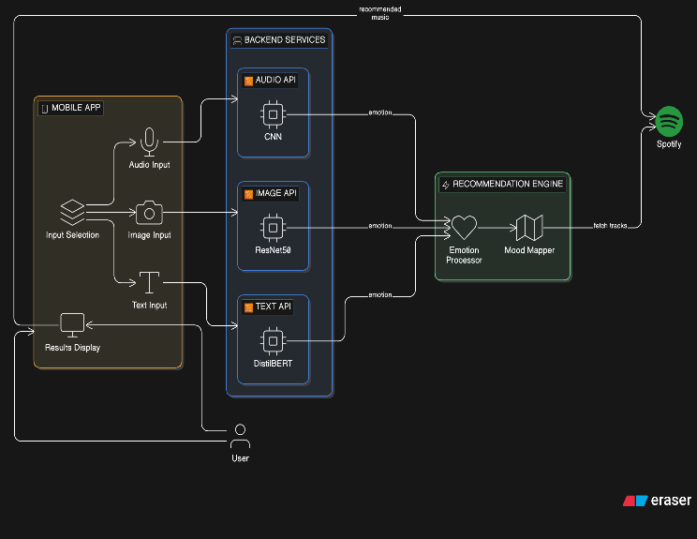
Diagram 5. 1: Architecture diagram of application
As per the architecture diagram, the working of the Moodify system, as a multi-modal emotion-aware music recommendation tool, as shown. As mentioned above, the flow of Moodify starts from the mobile application. Users can use their audio, images, or text input here, making the system more robust and accurate than single input emotion-aware systems. After the user gives the input, it will be sent to the backend services.
There are three backend APIs that will be used depending upon the type of input provided by the user. The first one is the Audio API, while the second one is the Image API. They make use of Convolutional Neural Networks and ResNet50 to make emotion predictions based on the input they receive. There is another backend API, the Text API, which utilizes the DistilBert model to make predictions based on text inputs. After receiving the emotions predicted by these APIs, the recommendation engine processes them and makes use of its components such as Emotion Processor and Mood Mapper to map these emotions to a suitable mood of music. Finally, after finding the appropriate music moods, the system sends requests to the Spotify database and retrieves recommendations for the user.
5.2 DATA FLOW DIAGRAM
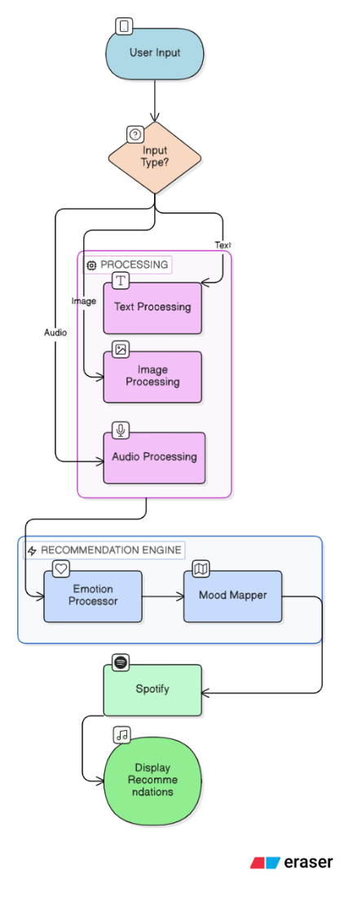
Diagram 5. 2: Data Flow diagram of application
The Data Flow Diagram (DFD) of the Moodify system illustrates how data moves between different components of the application, starting from user input to final music recommendation output. The process begins with the user interacting with the mobile application by providing input in the form of text, audio, or image. This input is then sent to the system’s backend, where it is directed to the respective processing modules based on the input type. Each module processes the data to extract meaningful emotional information, ensuring that the system accurately understands the user’s current mood.

Once the input is processed, the extracted emotional data flows into the central recommendation engine, which acts as the core of the system. Here, the Emotion Processor interprets the detected emotion and forwards it to the Mood Mapper, which maps the emotion to a corresponding music category or mood. This mapped data is then used to generate suitable music recommendations by interacting with external services such as Spotify. The recommended songs are finally sent back to the mobile application, where they are displayed to the user, completing the data flow cycle. The DFD effectively highlights the smooth and logical movement of data across modules, ensuring real-time processing and personalized music suggestions.
5.3 Use case Diagrams

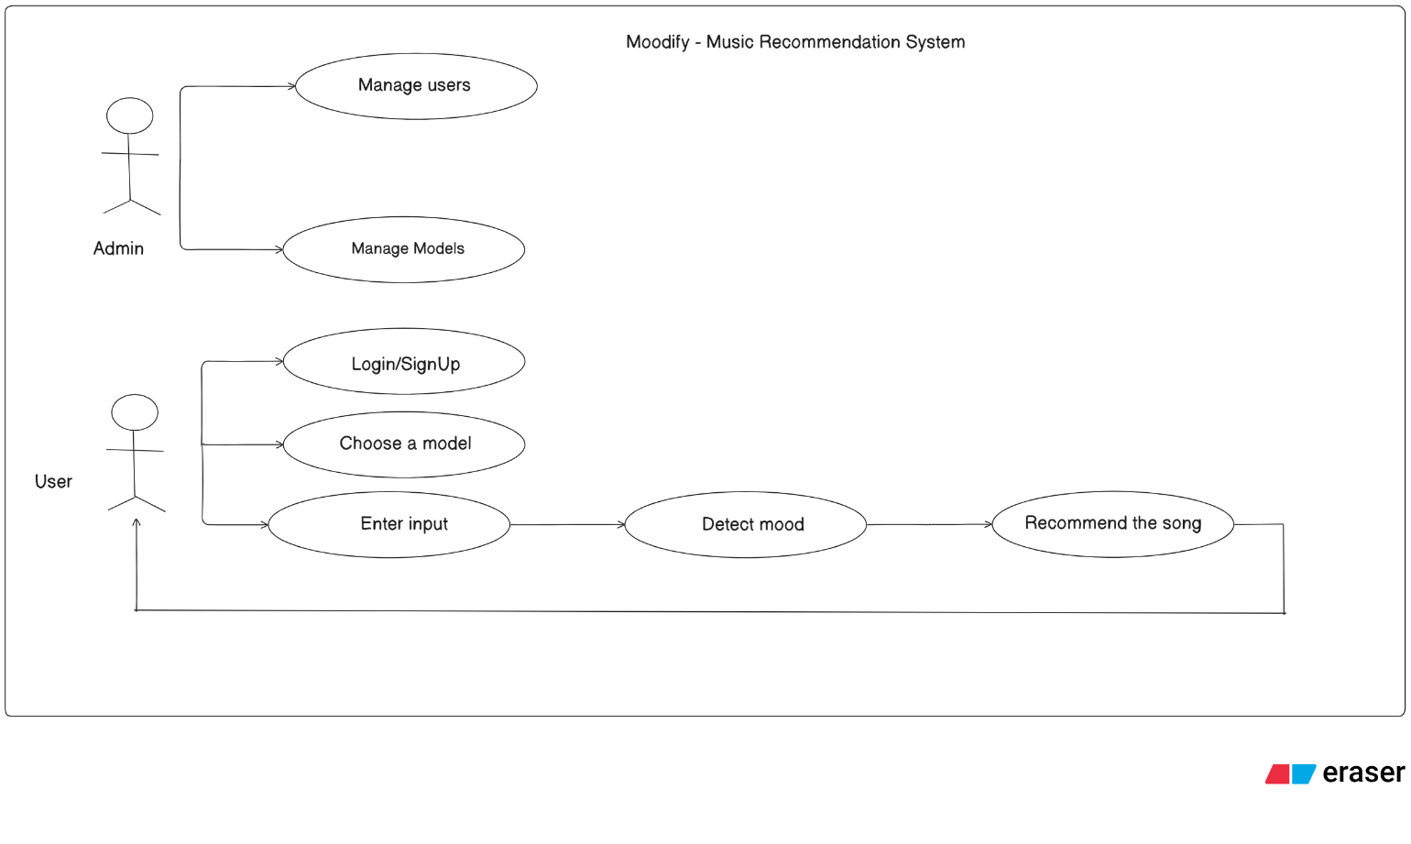
Diagram 5. 3: Use case diagram for application.

The following use case diagram outlines the general working pattern of the Moodify Music Recommendation System, indicating the engagement between the two main actors, namely the Admin and the User. As stated above, the admin deals with general administrative activities such as handling users' details and the models used to recognize and recommend emotions. These administrative duties make sure the system stays efficient and up-to-date to provide relevant outputs. Conversely, the User works with the application, starting with logging in or signing up before choosing an appropriate emotion recognition model.

Once logged in and after selecting a model for mood recognition, the user enters some data in the form of text, audio, or image files, which helps determine the user's current mood. After recognizing the user's mood, the system recommends music tracks based on the user's emotions. In this way, the user's experience becomes highly personalized since their emotional state affects the recommended songs.

5.4 Class Diagram
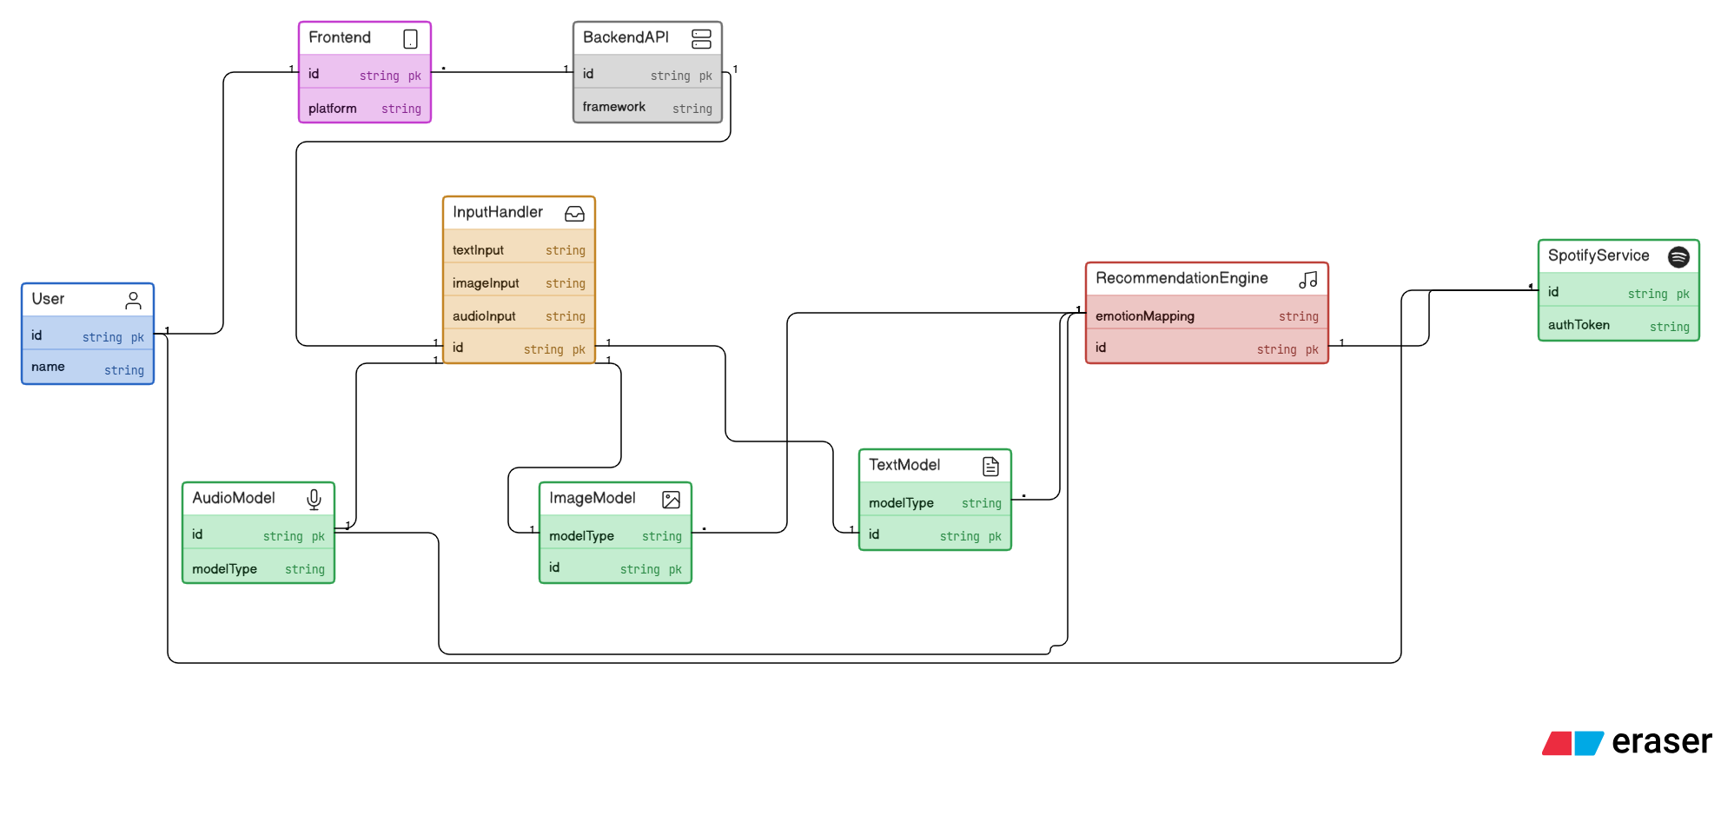
Diagram 5. 4: Class diagram for application

The figure below shows the class diagram of the Moodify system, whereby various classes are displayed alongside the relationships between them. The first class in the system is User. It includes attributes such as user id and name. It also works with another class called Frontend, which is part of the user interface layer of the application. In addition, the frontend class interacts with the backend API class as it serves as the link between the interface and the core logic of the application. The inputHandler class manages various types of input such as images, audio, and text inputs, storing them, and delivering them to the relevant modules.

The models involved in the system are represented by specialized classes that include audioModel, textModel, and ImageModel. They contain various attributes including model type and model id, which are machine learning models utilized in the process of detecting emotions. On the other hand, RecommendationEngine has attributes including emotion mapping and music recommendation logic that connects these models with the system. Finally, there is SpotifyService, which is linked to the Spotify platform via authentication tokens that enable the retrieval of songs.
5.5 Sequence Diagram
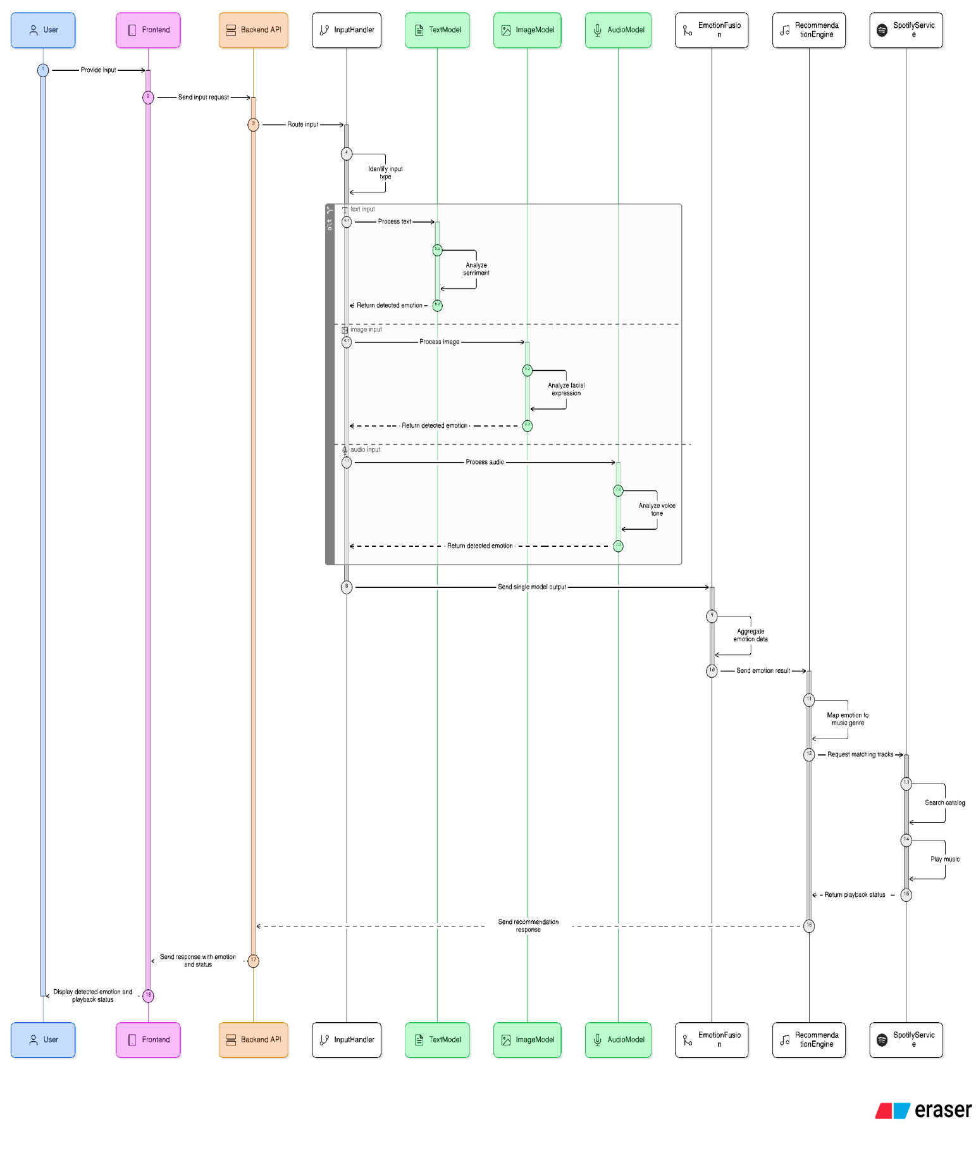
Diagram 5. 5: Sequence Diagram for application.
This figure shows a sequence diagram of the Moodify system, which demonstrates the interaction among various components involved in receiving input from users and producing music recommendations based on the emotions they convey. First, the User provides input in any form such as text, image, and speech via the Frontend component. Then, the Frontend component sends this input as a request to the Backend API component, which redirects this request to the InputHandler component. Depending on the nature of the input, the InputHandler component transfers this request to the corresponding model – TextModel for text input, ImageModel for image input, and AudioModel for speech input.
Then, the models analyze these inputs in parallel. Specifically, the TextModel conducts sentiment analysis on the text input, while the ImageModel analyzes the expression in the picture and determines the conveyed emotion. Similarly, the AudioModel examines the speaker’s voice and recognizes any emotion contained in it. After analyzing the input, the models return the detected emotion to the InputHandler component. When there is more than one type of input, the resulting emotions are sent by the models to the EmotionFusion component, which consolidates this information.
The aggregate emotional state is next transferred to the RecommendationEngine, where it is matched against appropriate genres or emotional categories. Based on the match, the system creates a request for the corresponding songs and interacts with the SpotifyService. The Spotify Service searches the songs within its database that match the provided information and either starts playing them or simply finds them in the catalog. Also, the state of playback and details of the selected tracks are returned back to the recommendation engine.
Finally, the recommendation results together with the emotional state and playback status are transferred back via the Backend API to the Frontend, where the detected emotion and music suggestions are presented to the user. This sequence diagram vividly demonstrates how each step of communication between different modules of the system occurs, reflecting the process of real-time processing and integration of various AI algorithms into one solution.

5.6 Activity Diagram
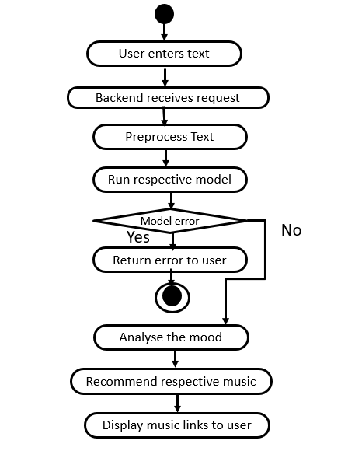
Diagram 5. 6: Activity diagram for application.
The activity diagram depicts how the Moodify software system performs its activities to recommend music depending on the emotional state of a person based on his or her textual input. It starts with user text entry, after which the input data are transmitted to the backend where the request is received. Then, data preprocessing takes place. It helps to cleanse and prepare the input data for analysis. After preprocessing, the model is used to interpret the entered data and extract necessary emotions from it.

Following that, the system detects an error if there was one during the use of the specific model. In case of a model error, an error message appears to be transmitted to the user, and further activities are not performed. If an error did not occur, the next step includes detection of user's mood using the prepared input data. Then, the system selects appropriate music and returns it together with the links to the user.

CHAPTER – 6

(IMPLEMENTATION)

6.1 SAMPLE CODE

This script trains a text-based emotion detection model using DistilBERT by preprocessing a Kaggle dataset, tokenizing text, and fine-tuning the model for classification. It then evaluates performance and saves the trained model and tokenizer for integration into the Moodify application.
# ============================================================================
# TEXT MODEL TRAINING - DistilBERT (Shortest Training Script)
# ============================================================================
import kagglehub
import pandas as pd
import torch
from sklearn.model_selection import train_test_split
from transformers import DistilBertTokenizerFast, DistilBertForSequenceClassification, Trainer, TrainingArguments
from datasets import Dataset
import glob
import os

# --- 1. DOWNLOAD & LOAD DATA ---
print("Step 1: Downloading dataset from Kaggle...")
path = kagglehub.dataset_download("kushagra3204/sentiment-and-emotion-analysis-dataset")
print(f"Dataset downloaded to: {path}")

# Find the csv file automatically
csv_files = glob.glob(f"{path}/*.csv")
if not csv_files:
# Try searching recursively if not in top folder
csv_files = glob.glob(f"{path}/**/*.csv", recursive=True)

if not csv_files:
raise FileNotFoundError("Could not find a CSV file in the downloaded Kaggle folder.")

print(f"Reading file: {csv_files[0]}")
df = pd.read_csv(csv_files[0])

# --- 2. CLEAN & PREPARE DATA ---
print("Step 2: Cleaning Data...")

# Check column names and rename them to 'text' and 'label'
print(f"Original columns: {df.columns.tolist()}")

# The specific Kaggle dataset usually has 'sentence' or 'text' and 'label' or 'emotion'
# We normalize this:
if 'sentence' in df.columns:
df = df.rename(columns={'sentence': 'text'})
if 'emotion' in df.columns:
df = df.rename(columns={'emotion': 'label'})

# Ensure we have the right columns
if 'text' not in df.columns or 'label' not in df.columns:
raise ValueError(f"Columns didn't match! Found: {df.columns}. We need 'text' and 'label'.")

# CRITICAL: Use a subset for faster training?
# 400k rows takes hours. Let's use 10k for a great balance of speed/accuracy.
# Change n=10000 to n=len(df) if you want to use ALL data (takes long time).
df = df.sample(n=10000, random_state=42)

# Create label mappings
unique_labels = df['label'].unique().tolist()
label2id = {label: i for i, label in enumerate(unique_labels)}
id2label = {i: label for i, label in enumerate(unique_labels)}

print(f"--> Detected Emotions: {unique_labels}")
df['label'] = df['label'].map(label2id)

# Split data
train_df, test_df = train_test_split(df, test_size=0.2)
train_dataset = Dataset.from_pandas(train_df)
test_dataset = Dataset.from_pandas(test_df)

# --- 3. TOKENIZATION ---
print("Step 3: Tokenizing...")
tokenizer = DistilBertTokenizerFast.from_pretrained('distilbert-base-uncased')

def tokenize_function(examples):
return tokenizer(examples['text'], padding="max_length", truncation=True, max_length=64)

train_tokenized = train_dataset.map(tokenize_function, batched=True)
test_tokenized = test_dataset.map(tokenize_function, batched=True)

# --- 4. MODEL SETUP ---
print("Step 4: Loading Model...")
model = DistilBertForSequenceClassification.from_pretrained(
'distilbert-base-uncased',
num_labels=len(unique_labels),
id2label=id2label,
label2id=label2id
)

# --- 5. TRAINING ---
training_args = TrainingArguments(
output_dir='./results',
num_train_epochs=2, # Reduced to 2 for speed
per_device_train_batch_size=8,
per_device_eval_batch_size=8,
eval_strategy="epoch",
save_strategy="epoch",
load_best_model_at_end=True,
)

trainer = Trainer(
model=model,
args=training_args,
train_dataset=train_tokenized,
eval_dataset=test_tokenized,
)

print("Step 5: Training Started...")
trainer.train()

# --- 6. SAVE ---
save_path = "./modify_bert_model"
print(f"Saving to {save_path}...")
model.save_pretrained(save_path)
tokenizer.save_pretrained(save_path)
print("Done! You can now run app.py")

CHAPTER – 7

(SCREENSHOTS)

7. SCREEN SHOTS
7.1 User Interface
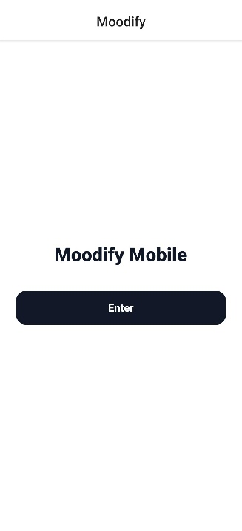
Figure 7. 1: User Interface of application
This figure is a simple welcome screen on the phone application "Moodify." This welcome screen is accompanied by an enter button leading the users to enter the application
7.2 Login

Figure 7. 2: Login page of Moodify

A simple and user-friendly sign-in screen allowing users to log in with their email and password.
It also provides a clear option for new users to navigate to the sign-up page.
7.3 Signup
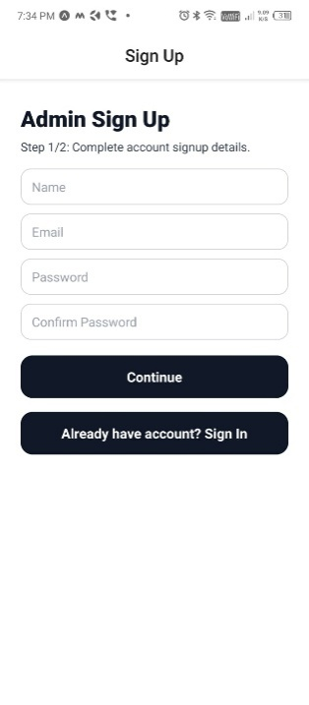
Figure 7. 3: Signup page of Moodify
An admin sign-up screen where users enter basic details like name, email, and password to create an account. It includes a step indicator and options to continue registration or return to the sign-in page.
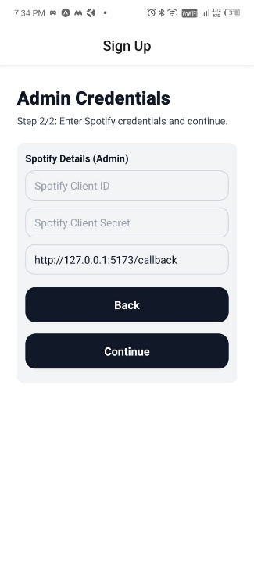
Figure7.3. 1. Admin credentials page
An admin credentials screen where Spotify Client ID, Client Secret, and callback URL are entered.
It allows users to go back or continue to complete the setup process.
7.4 Modes Interface
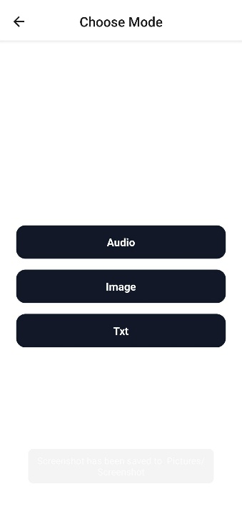
Figure 7. 4: Modes of inputs interface
A mode selection screen where users can choose between Audio, Image, or Text input options.It provides a simple interface to select how they want to interact with the app.
7.5 BERT(Text) Model interface
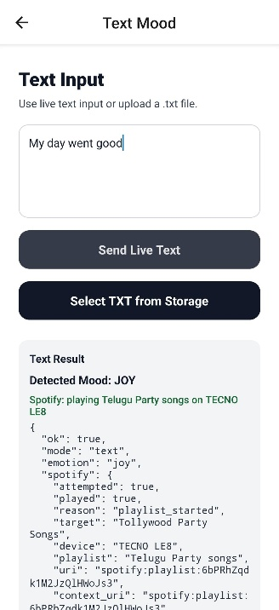
Figure 7. 5:DistillBert Model prediction
This screen shows a text mood detection feature where users can input or upload text. The system analyzes the text and identifies the detected mood as “Joy.”It also suggests playing Telugu party songs based on the detected mood. In the background, the model is DistillBert.
7.6 ResNet50(Image) Model interface
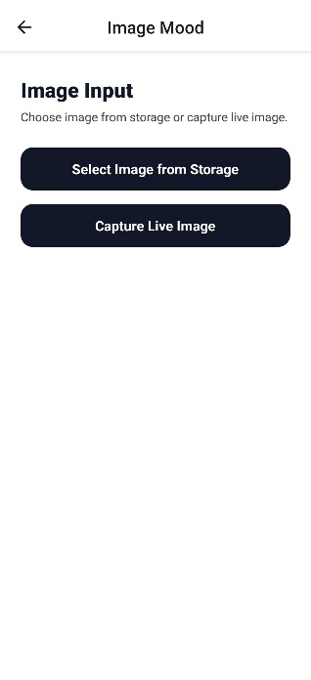
Figure 7. 6: ResNet50 Model interface
This interface allows users to upload or capture an image for mood detection using a ResNet50 deep learning model. It provides simple options for image input, enabling the model to analyze visual features and predict emotional context.
7.7 Librosa+CNN(Audio) Model interface
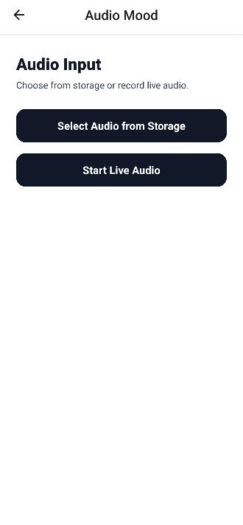
Figure 7. 7: CNN model interface for audio input
This interface enables users to select or record audio for mood detection using a Librosa + CNN-based model. It processes audio features like tone and frequency patterns to classify the emotional state from sound input.
7.8 Output
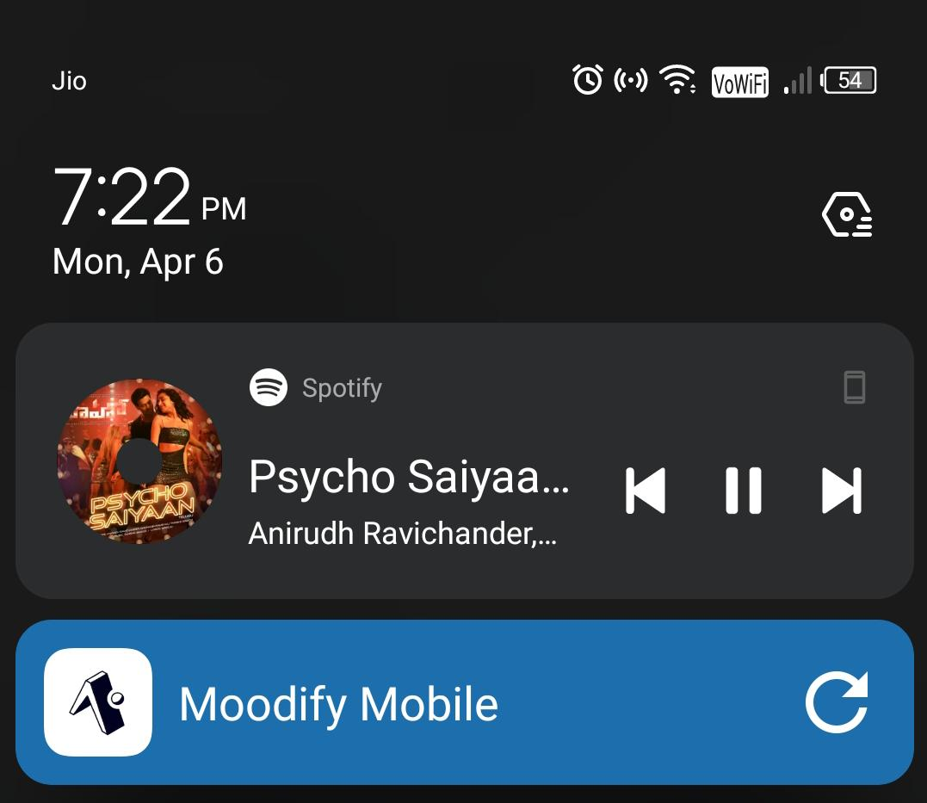
Figure 7. 8: Autoplayed song on spotify
This song is autoplayed on the mobile based on the recommendation made by the model through the detected mood.

CHAPTER – 8

(TESTING)

8. TESTING
8.1 Test Strategy

The test plan developed for this project aims at assessing the effectiveness, efficiency, reliability, and validity of the multimodal emotional detection program, which is capable of processing text, images, and audio data. The process incorporates several stages of the evaluation process to guarantee that all application parts function as intended alongside the artificial intelligence (AI) components. First, functional testing should be carried out to confirm that all operations, including inputting information, uploading files, and generating predictions, can be completed successfully.

Apart from functional testing, a set of other procedures will be applied to examine the effectiveness of the AI models in terms of accurate prediction of such emotions as happy, sad, angry, and nervous. As part of AI testing, the generalization capability of the AI models should be validated to confirm that predictions generated on the basis of different inputs remain consistent. Moreover, performance testing will be conducted to assess the responsiveness of the system.

Also, the security test is another significant aspect in the testing approach, as it will concentrate on dealing with situations that include special characters or even no input at all to avoid problems or any other vulnerability in the system. Through such tests, it can be ensured that the system will not face any issues in any situation that may arise while being used in the real world.
8.2 Test Cases
Table 8.2 Test cases
Test Case  #1D | Test Case Type | Test Case Description | Expected Value | Actual Value | Result
TC01 | Functional | User enters valid username & password | Login successful, redirect to dashboard | Redirected to dashboard | PASS
TC02 | Security | User enters invalid password | Error message displayed | Displayed | PASS
TC03 | Security | User enters invalid username | Error message displayed | Displayed | PASS
TC04 | Functional | User enters valid input | Input accepted for analysis | Accepted | PASS
TC05 | Functional | Submit input for prediction | Emotion predicted | Accepted | PASS
TC06 | AI | Detect happy emotion | Emotion: Happy | Joy | PASS
TC07 | AI | Detect sad emotion | Emotion: sad | sad | PASS
TC08 | AI | Detect angry emotion | Emotion: angry | Angry | PASS
TC09 | AI | Detect nervous emotion | Emotion identified correctly | Identified | PASS
TC10 | Functional | Backend API (/predict) call | JSON response returned | Returned | PASS
TC11 | Performance | Response time under 5 seconds | <5 seconds | Within Limit | PASS
TC12 | Security | Empty text submission | Error message shown | Shown | PASS
TC13 | Security | Special characters input | Handled Safely | Handled | PASS
TC14 | Validation | Upload unsupported file | Error message shown | shown | PASS
TC15 | AI Robustness | Noisy audio input | Emotion detected | Detected | PASS

CHAPTER – 9

(RESULTS)

9. RESULTS
The audio model is the best performing model compared to the other modalities. The audio model can achieve an accuracy of 85.23% while the values of precision, recall, and f1 scores fall within the range of 0.85. This can be seen from the dominance along the diagonals in the confusion matrix, which indicates that the majority of the emotions such as happiness, neutral and angry are correctly classified. This is because acoustic features such as pitch, tone, and intensity are very effective when it comes to conveying human emotions.
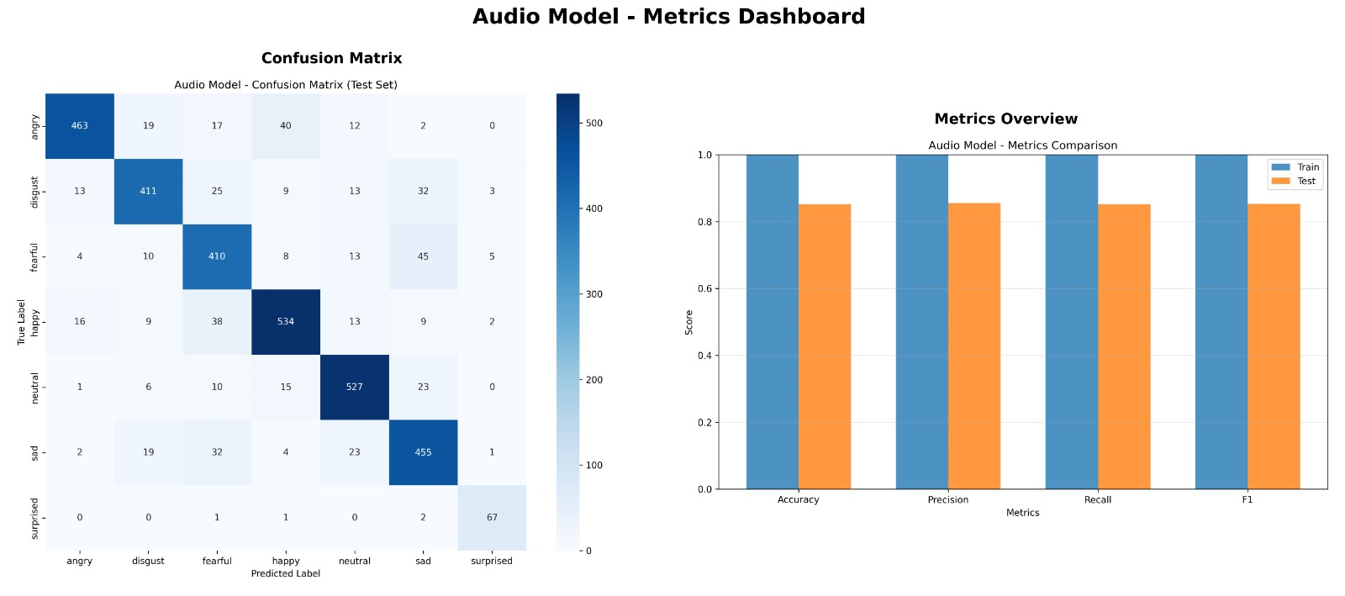
Figure9. 1: Audio Model metrics comparision
The image model is able to achieve average accuracy levels of 50.03%. In addition, precision, recall, and f1 scores have values within the range of 0.50. This is clearly indicated through the confusion matrix, which shows very high cases of misclassification between different emotional classes. This mainly applies to fear, sad, and neutral classes. This could be because of the challenges involved in extracting features from images, considering the changes in lighting and orientation.
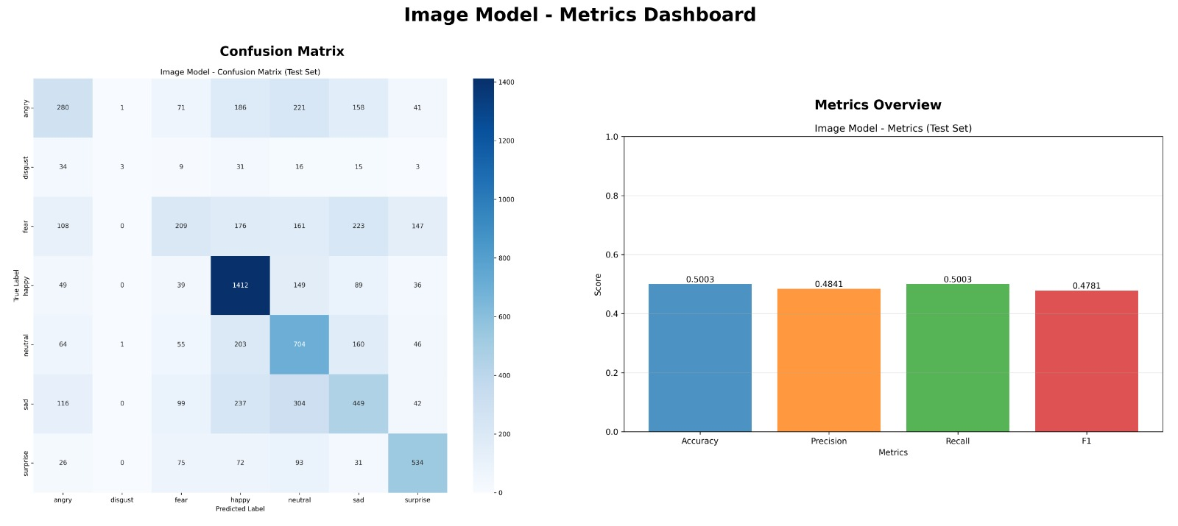
Figure9. 2: Image Model metrics comparision

From the above analysis, the text model demonstrates intermediate performance with a precision of 71.23%. The precision, recall, and f1 scores are generally lower. This can be seen from the confusion matrix above, which shows the high amount of misclassification of various states of emotions. This is especially true in the case of the misclassification of joy and love. While DistilBERT offers very promising performance, the efficiency of its use depends heavily on the quality of data available.
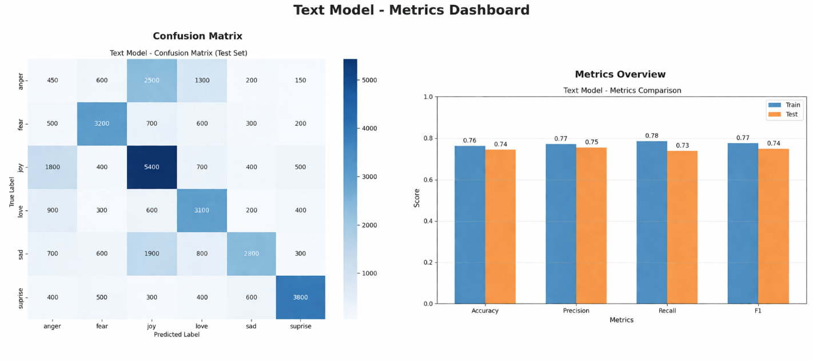
Figure9. 3: Text Model metrics comparision
On the other hand, the outcome obtained is clear about the fact that the audio model has performed better than the text and image models, which have performed less. However, each of the models comes with its own strengths, where the audio model comes with accuracy, the text model offers a better understanding of the context, and the image model with emotions, which makes it easier for the users to recognize their emotions through visual cues. It is expected that the application of all three models will result in improved system performance as the strengths provided by each of them will be put into consideration to get highly accurate results.
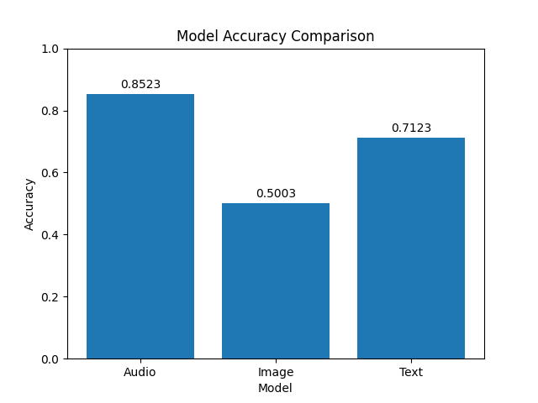
Figure9. 4: Model accuracy comparision

The system was evaluated using accuracy, precision, recall, and macro-averaged F1-score on the held-out test set. Table 9.1 presents performance for depression severity classification.
Table 9.1 Performance Metrics
Model | Precision | Recall | F1
Text Model | 0.77 | 0.78 | 0.77
Image Model | 0.48 | 0.50 | 0.47
Audio Model | 0.85 | 0.82 | 0.85

The proposed based system was compared with baseline methods on depression severity classification accuracy (Table 9.2)
Table 9.2 Comparative Metrics
Model | Accuracy
BERT | 0.71
ResNet50 | 0.50
Librosa+CNN | 0.85

CHAPTER – 10

(CONCLUSION AND FUTURESCOPE)

10. CONCLUSION AND FUTURESCOPE
10.1 Conclusion
The Moodify: Emotion-Based Music Recommendation System successfully demonstrates how artificial intelligence can be used to enhance user experience through personalized music suggestions. By integrating multimodal emotion detection using text, image, and audio inputs, the system provides a more comprehensive understanding of user emotions. The use of deep learning models such as DistilBERT, ResNet50, and CNN enables accurate emotion recognition, making the system intelligent and adaptive. The seamless interaction between frontend, backend, and external music services ensures a smooth and responsive user experience. Overall, the project highlights the potential of combining AI and entertainment to create meaningful and engaging applications.

The system is designed with a modular and scalable architecture, allowing easy integration of new features and technologies in the future. The separation of components such as input handling, model processing, and recommendation generation ensures maintainability and flexibility. The use of FastAPI for backend and React Native for frontend contributes to efficient performance and real-time interaction. Additionally, the integration with Spotify enhances the practicality of the system by enabling actual music playback. This architecture makes the system suitable for both academic exploration and real-world deployment.
10.2 Future Scope

In the future, the system can be enhanced by incorporating advanced models such as transformer-based multimodal architectures and large language models for deeper emotional understanding. Personalization can be improved by integrating user behavior analysis, playlist history, and feedback mechanisms. The addition of multilingual support will make the system accessible to a wider audience. Furthermore, deploying the system on cloud platforms can improve scalability, reliability, and accessibility across devices.

Another promising direction for future work is the integration of real-time adaptive learning and mental wellness support features. The system can be extended to provide mood tracking, daily insights, and suggestions for improving emotional well-being. Integration with wearable devices or IoT systems can enable continuous emotion monitoring. Additionally, improving the recommendation engine using collaborative filtering or hybrid recommendation techniques can enhance accuracy. These advancements can transform Moodify into a more intelligent, personalized, and impactful emotional support and entertainment platform.

CHAPTER – 11

(REFERENCES)

11. REFERENCES

[1] A. van den Oord, S. Dieleman, and B. Schrauwen,
“Deep Content-Based Music Recommendation,” Advances in Neural Information Processing Systems (NeurIPS), 2013.

[2] M. Kim, D. Kim, et al., “An Emotion-oriented Music Recommendation Algorithm Fusing Rating and Trust,” 2014.

[3] S. K. Kim and S. B. Park, “An Emotion-Aware Personalized Music Recommendation System Using CNN Approach,” 2018.

[4] L. Parisi, S. Francia, et al., “Exploiting Synchronized Lyrics and Vocal Features for Music Emotion Detection,” 2019.

[5] Y. Zhang, T. Liu, et al., “A Novel Emotion-Aware Hybrid Music Recommendation Method Using Deep Neural Network (emoNR),” 2022.

[6] S. Gilda, H. Zafar, C. Soni, and K. Waghurdekar, “Smart Music Player Integrating Facial Emotion Recognition and Music Mood Recommendation,” 2017.

[7] A. V. Iyer, V. Pasad, S. R. Sankhe, and K. Prajapati, “Emotion-Based Mood Enhancing Music Recommendation,” 2015.

[8] V.P. Sharma, etal., “Emotion-Based Music Recommendation System,” 2019.

[9] S. R. Livingstone and F. A. Russo, “The Ryerson Audio-Visual Database of Emotional Speech and Song (RAVDESS),” PLoS ONE, 2018.

[10] H. Cao, D. G. Cooper, M. K. Keutmann, R. C. Gur, A. Nenkova, and R. Verma, “CREMA-D: Crowd-sourced Emotional Multimodal Actors Dataset,” IEEE Transactions on Affective Computing, 2014.

[11] M. Abadi et al., “TensorFlow: Large-Scale Machine Learning on Heterogeneous Systems,” 2015.
[12] T. Akiba et al., “Optuna: A Next-generation Hyperparameter Optimization Framework,” in Proceedings of the ACM SIGKDD International Conference on Knowledge Discovery and Data Mining, 2019.

[13] B. McFee et al., “librosa: Audio and Music Signal Analysis in Python,” in Proceedings of the 14th Python in Science Conference, 2015.

[14] S. Hochreiter and J. Schmidhuber, “Long Short-Term Memory,” Neural Computation, 1997.

[15] A. Paszke et al., “PyTorch: An Imperative Style, High-Performance Deep Learning Library,” in Advances in Neural Information Processing Systems, 2019.

